- Bean Shell is used to write variables/modify variables in JMeter scripts
- Where we can write simple logics using java script.
- We can create bean shell under thread group
- Thread Group -> right click and select sampler -> Bean shell sampler
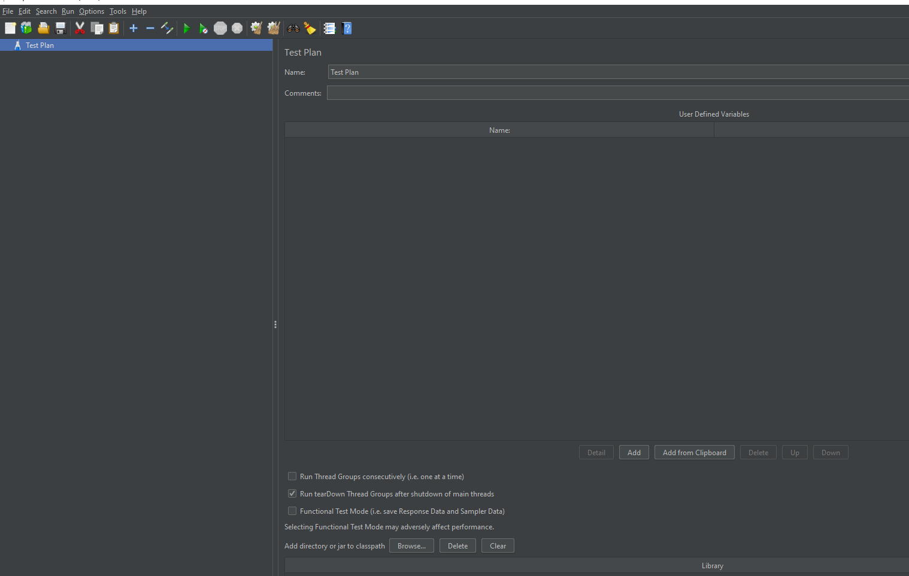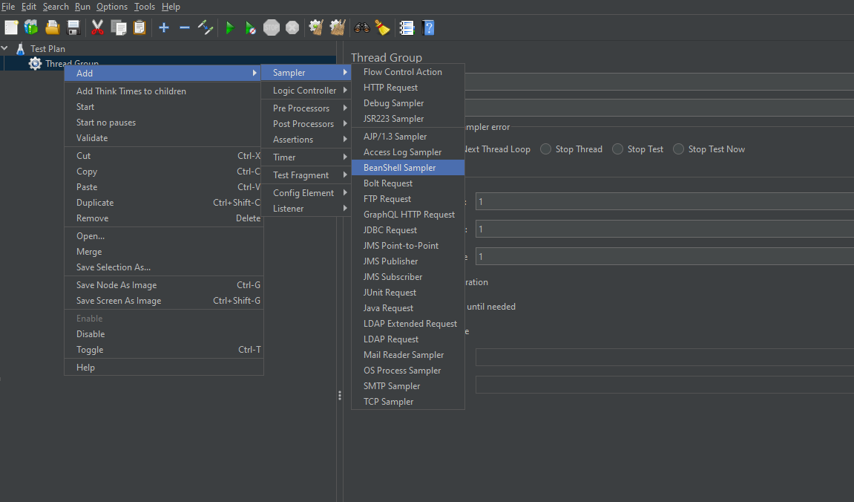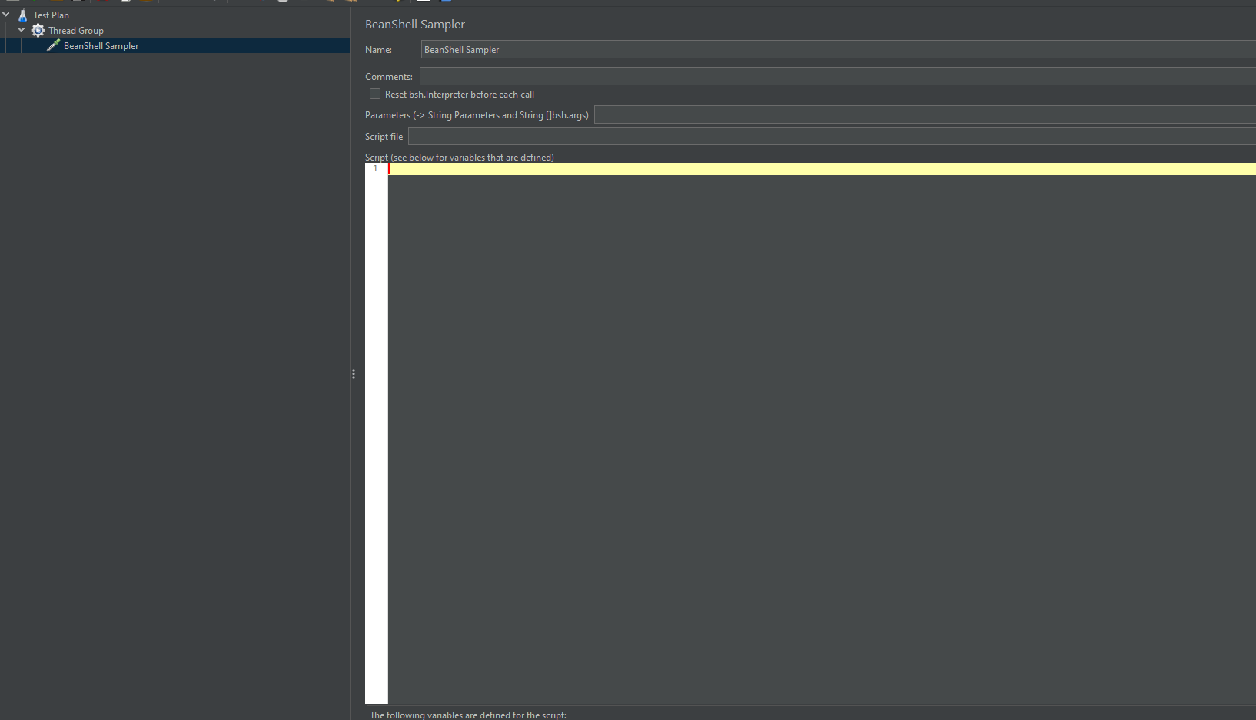

- whatever we write in beanshell sampler, we will get it in console if we use logs that we can see in next document

